ATP CTP Frequently Asked Questions and Answers

Q. Is the class accomplished in a specific aircraft?
A. No, the program is not aircraft specific. This course is approved as FAA ATP CTP in our FAA 142 Specialty Curriculum. Upon completion you will be booked into one of the simulators that are available. The aircraft might change based upon which simulator is available during your class, and we cannot take requests as to which simulator will be used. Current courses utilize Falcon, Gulfstream, Embraer 145, 737-800 and Challenger 601.
*NOTE: Due to TSA requirements, non-US citizens will be required to add aircraft type and will not be changed.

Q. What type of material will I receive for pre-study? Is it required? Is there anything else I can receive?
A. We offer a Dropbox link with pre-study material included. The Dropbox pre-study material is not required, but it is highly recommended to be reviewed and studied. Once you are here, if you would still like to receive more material, we can set you up with an E-Learning course user name and password. Just stop by our customer services desk to request it.

Q. How long is the course? Are there any days off during the course?
A. The course is 7 days in length, including 4 days of ground training and 3 days in the simulator. Ground school runs roughly 0900-1730 each day. Your schedule may vary by time in the simulator, so we suggest all departing flights be scheduled on the 8th day. No days off are planned during the course.

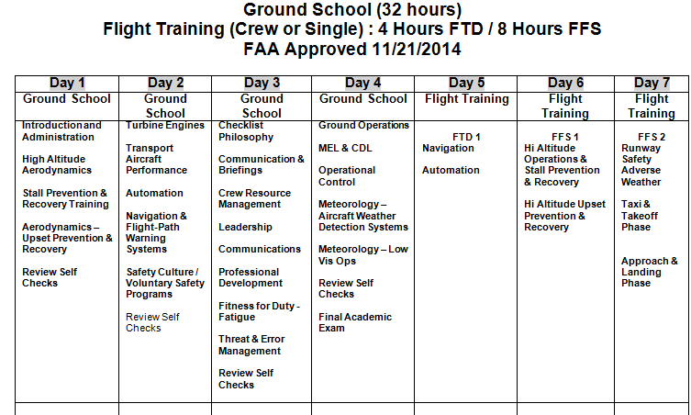

Q. Are hotels included in price and can you schedule them for us? Is there a special CAE hotel rate?
A. The price of the course does not include travel, lodging or car rental. We do have client services representatives who can help you schedule hotel, car rental & airline reservations. We do receive special rates from local hotels. Please contact our representatives from Signature Travel Services directly at:
Pina Saputo: Tel (972) 456-8364 - CAE Direct | Fax (972) 584-0449 | Emergency - (210) 568-7847 pina@signaturetravelservices.com
Jenn Dockery: Tel (972) 456-8364 - CAE Direct | Fax (972) 584-0449 | Emergency - (210) 568-7847 jenn@signaturetravelservices.com

Q . What can I expect to receive from CAE?
A. 1. Conformation email confirming the date, time , info about our building.
2. Below is a drop box link to our pre-study material
https://www.dropbox.com/sh/qvst8jzz2s6uszg/AADfFSrMes6kuBPzQaZzeEhga?dl=0
Q. How often do you offer the class?
A. We currently offer classes every Monday (except holiday weeks).

Q. Do you administer the ATP CTP written exam after the ATP CTP class is completed? If not, can you tell us who does? When can I take the test?
A. At the present time, CAE does not offer the FAA ATP written exam. We can suggest American Flyers, but we are not partnered with them in any way. There are numerous flight schools in Dallas-Fort Worth area that offer computer testing. Once you complete the ATP CTP course at CAE, you must wait 24 hours before you can take the FAA written exam.

American Flyers 972-407-0295 16151 Addison Road, Addison, TX 75001 mitch_m@af.tv

Q. Is the ATP CTP course knowledge exam the same thing as the FAA written exam?
A. No. The ATP CTP knowledge written exam is not the FAA written exam. During the ATP CTP course you will be
given review exercises at the end of the first 3 days of class. On Day 4 of the class, the final exam will be administered. Upon completion of the course, you may then take the FAA ATP knowledge test through outside sources (24 hours after completion of the ATP CTP course).

Q What are requirements for a non-US Citizen?
A. Non-US citizens are subject to Transportation Security Administration (TSA) screening and are responsible for all associated fees.

Q. What are the prerequisites to enroll in the class?
A. CAE FAR Part 142 ATP CTP Curriculum - 1.2 Course Prerequisites Pilot-in-Command (PIC) and Second-in-Command (SIC) trainees must meet the minimum eligibility requirements of Part 61 - 61.153 (a,2)(b) and (d), and 61.160 if a pilot qualifies for the Restricted ATP.
• Minimum Age 23 (if 21, qualifies under 61.160) to hold an ATP Rating
• Military experience per FAR 61.73 or Commercial Pilot Certificate with Instrument Rating
• ATP Written
Must have completed an ATP CTP course if the FAA ATP exam is taken after July 31, 2014
• Instrument Proficiency
• Flight Time per FAR 61.159 requirements:
1,500 Hours Total Time:
500 Hours Cross Country Time
100 Hours Night Time
75 Hours Instrument Time of Actual or Simulated Instrument Time:
50 Hours must be in an airplane
50 hours must be multiengine flight experience
250 Hours PIC Airplane
• For a Restricted ATP under FAR 61.160:
Minimum age of 21
And meet any of the requirements of 61.160 (a thru h)
** Also note . . . The ATP CTP graduation certificate does not expire, however once you take the ATP knowledge test (written) - you must pass the ATP flight practical test within five years (60 months).

Q. What is CAE’s dress code?
A. We officially do not have a dress code. We suggest business casual.
Q. What documents will I need when checking in?
A. You will need a valid passport and your commercial pilot’s license. No medical is required.
Q. Can I take an ATP check ride immediately after completing the course?
A. You must wait 24 hours after completing the ATP CTP course before you can take the written. For the ATP upgrade class, you must have the written completed prior to the check ride.

Q. What other CAE facilities have the ATP CTP course available?
A. Currently Dallas is the only center we have approved. More training centers will be added in the future.

Q. Does ATP CTP result in a type rating?
A. No. The ATP-CTP class is a prerequisite class required before taking the ATP written test thru outside sources. No type ratings are issued through ATP CTP, however clients may enroll in an Initial Type Rating Course (IA) as a separate training event.

Q. What do I receive as evidence of ATP-CTP Completion?
A. You will receive a completion certificate that you will take to the testing location for the written. The completion certificate is your authorization to take the FAA ATP written exam.

Q. Is a TSA security clearance required of Non-US citizens ? if so, what category needs to be selected?
A. Yes it is required. Currently it will be Category 1 or 2, we are working with the TSA to see if we can change this.

Q. Is a pilot from a non-ICAO country eligible to take the ATP CTP course?
A. The current prerequisite requirements through the FARs state that only ICAO member state countries qualify for the course, but thru FAA approvals certain countries may be granted waivers to attend the course. This will need to be determined prior to course booking.

